7/30 PunchList
¨ Help Users Guide does nothing
¨ Release Notes need to be updated

7/29 Tests
☑ Test TrackFedex Link
¨ Timeline: Test click anywhere on timeline makes sense:
☑ Event
☑ Course
¨ Holiday (anywhere in column) Fail: Should show event editor
¨ Blank Area: Fail: Should show free editor. New Bug
☑ Row Head
¨ Legend: Fail: mouseout doesn’t if item is under scroll bar
¨ Drag event to timeline: should show event editor, shouldn’t be editable in place. Wont save.
¨ Employee Editor
☑ Contact Info
☑ Schedule Preference

7/29 Punch List
☑ Drag new event to timeline should select it and show editor
☑ Not saving new event.
☑ Bug: Make a second change to an event doesn’t light the save button
¨ Readonly Button doesn’t do anything: Test: enable readonly, modify and save an event.
☑ Event Editor: Duration(days) wrong. Click Barb on 7/21. Happens only on one day events. Doesn’t seem to happen in old version. It just doesn’t change the prev value. New one day event shows two days.
☑ click Blank Area: Fail: Should show free editor. New Bug
☑ Course Qualifications: doesn’t change to honor blank date clicked on.
¨ Click Holiday (anywhere in column) Fail: Should show event editor
☑ Focus on proper field at login
☑ Save the size of the timeline, nav pane and editor panes. New Feature.
☑ Don’t save state if not logged in.
☑ Legend: Add mouseout to entire legend container so it clears the desc.
¨ Print preview is awkward

Changes:
Added Employee Tab
Contact info from Sugar
Schedule Preference display
Schedule preference editor
Notes Tab
Notes Editor
Course Qualifications Display
Course qualifications editor.

NavBar: Cleaned month labels, lightened even month bars
Legend: Cleaned up, fixed geometry

7/17/10: Punch List:
¨ Legend: Fix Hold
¨ Test schedule pattern
¨ Fix filter date
From date not applying

¨ re-dock event editor
¨ Course Qualifications

Shedule pattern tests:
¨ click on instructor:
When a date is not associated with the click then the date panel is hidden and the current schedule is displayed
¨ honors effective date
☑ display: no schedule defined when appropriate
¨ delete a preference

¨ Clean up code
¨ Crash if excel is aborted
☑ Track link
☑ Options reset label hidden
¨ DateRange filter doesn’t get applied at first
☑ Instructor(3) tab on startup
☑ Clear legend text on mouseout
¨ Make timeline editable false
☑ smaller subtext in login box
¨ Click on rowhead doesn’t set tab text
¨ Apply date filter buttons need to attach right

¨ Deploy

◻ black line on first day of month

◻ List report: clean up & run silent
◻ Application.DoEvents during reports
◻ Calendar report: fix colors
◻ Calendar report: icons
◻ Calendar report: stack comments
◻ Calendar report: Move double line below week head
◻ Calendar report: Fix thick line
◻ Calendar report: page numbers

◻ Sugar: add start & end date to listview
◻ Sugar: double check the start/end date / duration javascript interaction code.
◻ Save filter & app state settings

Since Last Meeting
☑ Improve speed of drawing the nav bar by drawing to an image and only refreshing when
☑ Add time to date generated on calendar report
☑ class full indicator color is always the same as the appt status color (but darker for contrast)
☑ Instructor call & conferences pink
☑ Add “Available” to legend
☑ figure out a good lighter yellow for held
☑ Fix row selection highlight when an ee is expanded.
☑ Changed highlight from color to an outline.
☑ Improve nav bar item colors
☑ Fix course description of “off” (was showing stupid text in the class notes field when you selected an “off” appt.)
☑ fix off hover text (was showing stupid text in the hover field over “off” appt)
☑ Make appt edit panel like sugar (but readonly)
(this took the most time… added all the fields from the sugar edit screen and wired them up to data)
☑ Added the selected item summary bar between the nav bar and the edit pane to show who and when you clicked on.
☑ Changed so when you click on a non-appointment it shows info about the selected row/col (aka person/date) on the selected item summary bar and hides the edit form. Less annoying to the user.
☑ Added Load / Refresh progress bar.
☑ Make sure all appt types are marked with the correct IsExclusive flag
☑ Make sure all appt types are marked with the correct IsWorking flag
☑ Test that off overlapping available is marked as error
☑ If Class | TeamTeach | Observer overlaps weekend, Triangle.
☑ Change (none) → unassigned
☑ Fix instructor order: (barb/angie)
☑ Fix instructor order: unassigned at bottom

☑ Don’t flag adjacent appts as overlapping

For 3/23 since last meeting
☑ JG Filter: Sort Account filter list alphabetically
☑ TJ Filter: Add Public/Onsite Filter
☑ JG Filter: Move exceptions out from under courses to top level
☑ JG Filter: Tweak icons for unassigned
☑ JG Filter: Add “All B2t” Filter
☑ JG Filter: Fix the min and max dates
◻ JK Filter: Add Class Status Filter (fix confirmed)

☑ KQ Legend: Add population bar
☑ JG Legend: population bar honors display settings
☑ JG Legend: auto scrollbar – fit width

☑ JG Courses: Fix icon

☑ JK TimeLine: Put events on their own row
☑ JG TimeLine: Tweak instructor error icon
◻ JK TimeLine: All items in increments of one day
◻ TJ TimeLine: Thin black line on first day of month

☑ JG Nav Panel: Don’t mark past as red
☑ JG Nav Panel: Refresh when timeline min and max dates are changed

☑ JG Detail Panel: Hide bottom tab labels
☑ JG Detail Panel: Show different tab for events than class
☑ TJ Detail Panel: Add shipping address r/o
☑ TJ Detail Panel: Add Num Registered use as class size bar source
☑ TJ Detail Panel: Add Num Students

◻ TJ Calendar report: fix colors
◻ TJ Calendar report: icons
◻ JG Calendar report: stack comments
◻ JG Calendar report: Move double line below week head
◻ JG Calendar report: Fix thick line
◻ TJ Calendar report: page numbers
◻ JG Calendar report: Application.DoEvents
◻ JG Calendar report: run silent
◻ JG List report: Application.DoEvents
◻ JG List Report: run silent

☑ JG Sugar: check & r/o the “all day flag”
☑ JG Sugar: change the duration algorithm to add one day.
☑ JG Sugar: Hide “Status”
☑ JG Sugar: Hide “Team” (?)
☑ JG Sugar: Use dummy person as event (allb2t)
◻ TJ Sugar: add start & end date to listview
◻ TJ Sugar: double check the start/end date / duration javascript interaction code.
◻ JG Sugar: When saved with “All Day” checked, it saves as midnight start and end times

For 3/23 since last meeting

☑ JG TimeLine: Make selected item visible when timeline looses focus
◻ JG TimeLine: tooltip for date strip
☑ TJ TimeLine: show subject of all events
☑ TJ EditPanel: Rename “unassigned” in dropdown to “”
◻ Sugar: Make person required, subject optional.
☑ JG install package
◻ Prompt for username/pwd
◻
◻ Save filter & app state settings

Future Ideas:
◻ DisplayOptions: Drag to re-order display options
◻ DisplayOptions: Tristate parent nodes
◻ Filter: Tristate parent nodes

Open issue:

The edit form fields are pretty cramped. Suggestions welcome.

Done Today
☑ class full indicator color is always the same as the appt status color (but darker for contrast)
☑ Instructor call & conferences pink
☑ Add “Available” to legend
☑ figure out a good lighter yellow for held
☑ Fix row selection highlight when an ee is expanded.
☑ improve nav bar item color
☑ fix course description of “off” (was showing stupid text in the class notes field when you selected an “off” appt.)
☑ fix off hover text (was showing stupid text in the hover field over “off” appt)
☑ Make appt edit panel like sugar (but readonly) (this took the most time… added all the fields from the sugar edit screen and wired them up to data)
--- Also
Added the selected item summary bar between the nav bar and the edit pane to show who and when you clicked on.
Changed so when you click on a non-appointment it shows info about the selected row/col (aka person/date) on the selected item summary bar and hides the edit form. Less annoying to the user.
--- Open issue:
The edit form fields are pretty cramped. Suggestions welcome.

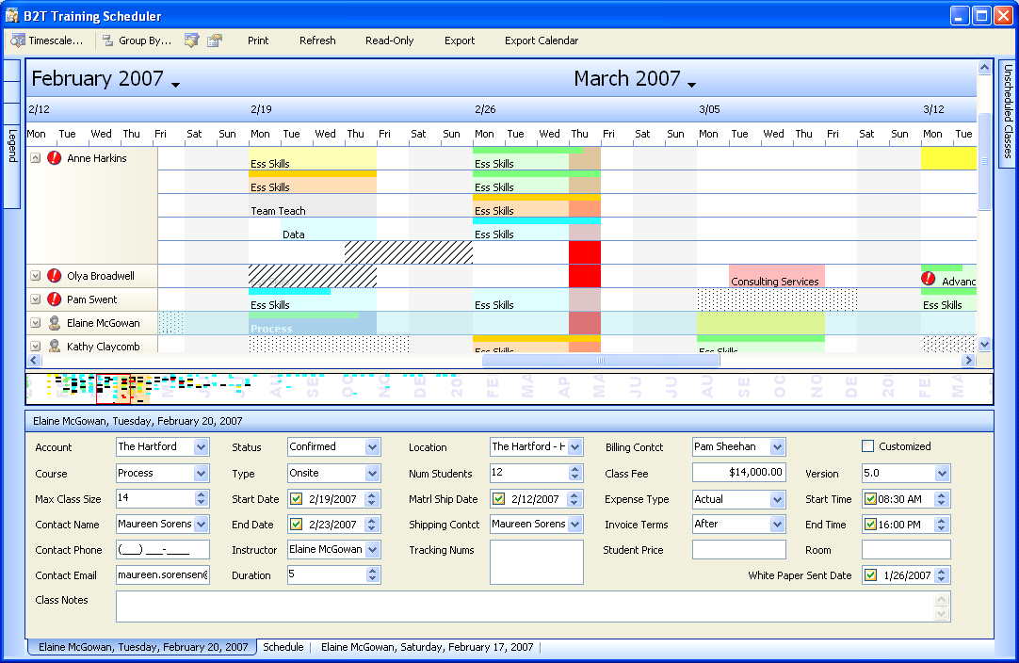
_____________________________________________
From: Kupe [mailto:kupe@b2ttraining.com]
Sent: Wednesday, March 14, 2007 5:04 PM
To: 'Jeff Gilbert'
Subject: RE: Mornin'

This all looks great to me. Can you just clarify a few of the items for me. Just give me another sentence of exactly what has to be done for the following items:

◻ 3/15 fix course description of “off”
◻ 3/15 fix off hover text

Thanks

Kupe,

Director of Business Analysis

B2T Training

678-287-0403

http://www.b2ttraining.com/

_____________________________________________
From: Jeff Gilbert [mailto:jgilbert@b2ttraining.com]
Sent: Wednesday, March 14, 2007 11:07 AM
To: 'Kupe'
Subject: FW: Mornin'

Again…
<< OLE Object: Picture (Metafile) >>
From: Jeff Gilbert [mailto:jgilbert@b2ttraining.com]
Sent: Wednesday, March 14, 2007 11:07 AM
To: 'Kupe'
Subject: FW: Mornin'

Ahh, here we go. If I format it as “Rich Text” instead of html it seems to look right…

<< OLE Object: Picture (Metafile) >>
From: Jeff Gilbert [mailto:jgilbert@b2ttraining.com]
Sent: Wednesday, March 14, 2007 9:58 AM
To: 'Kupe'
Subject: RE: Mornin'

Morning –
Here’s a quick snapshot of where I am and where I’m going. Your thoughts, additions, priority adjustments are welcome.

☑ Improve speed of drawing the nav bar by drawing to an image and only refreshing when necessary
◻ 3/15 black line on first day of month
☑ class full indicator color is always the same as the appt status color
☑ Instructor call & conferences pink
☑ Add “Available” to legend
☑ figure out a good lighter yellow for held
☑ Fix row selection highlight when an ee is expanded.
☑ improve nav bar item color visibility

◻ 3/15 fix course description of “off”
◻ 3/15 fix off hover text
◻ 3/15 Make appt edit panel like sugar
◻ 3/15 Fix instructor order: (barb/angie)
◻ 3/15 Fix instructor order: unassigned at bottom
◻ 3/15 Change (none) → unassigned

◻ 3/15 don’t flag adjacent appts as overlapping
◻ 3/15 If Class | TeamTeach | Observer overlaps weekend, Triangle.
◻ 3/15 Make sure all appt types are marked with the correct IsExclusive flag
◻ 3/15 Make sure all appt types are marked with the correct IsWorking flag
◻ 3/15 Test that off & available are marked as error

☑ Add time to date generated on calendar report
◻ 3/19 List report: clean up & run silent
◻ 3/19 Application.DoEvents during reports
◻ 3/19 Calendar report: fix colors
◻ 3/19 Calendar report: icons
◻ 3/19 Calendar report: stack comments
◻ 3/19 Calendar report: Move double line below week head
◻ 3/19 Calendar report: Fix thick line
◻ 3/19 Calendar report: page numbers

◻ 3/23 Sugar: add start & end date to listview
◻ 3/23 Sugar: double check the start/end date / duration javascript interaction code.

◻ 3/30 Save filter & app state settings

<< OLE Object: Picture (Metafile) >>
From: Kupe [mailto:kupe@b2ttraining.com]
Sent: Wednesday, March 14, 2007 9:43 AM
To: 'Jeff Gilbert'
Subject: Mornin'

Sometime this morning can you send me your punch list with est. completion dates for each item or group of items. With me possibly being out before you are dev complete, I need to be able to give some specific deliverable dates to Angie. This will also help me ensure you and I have the same thoughts on priority. Thanks

Kupe, ,

Director of Business Analysis

http://www.b2ttraining.com/

